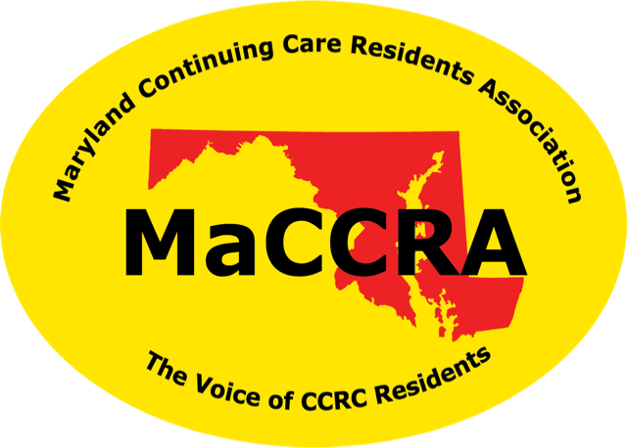
Maryland Continuing Care Residents Association

The Voice of Continuing Care Residents

Your Name, President
Address
email • phone

